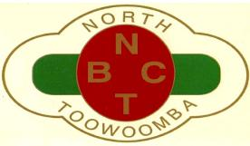
NORTH TOOWOOMBA BOWLS CLUB INC.
SOCIAL MEMBERSHIP APPLICATION
Fee $5 for 5 years
I hereby make application to be admitted as a SOCIAL MEMBER of the North Toowoomba Bowls Club Inc. and I declare I am over the age of Eighteen (18) and legally entitled to apply for membership of a licensed Club. I have been advised that the club has a $10 million public liability insurance policy.
If elected to membership, I agree to comply with all rules, by-laws and government regulations which govern the conduct of the Club.
NAME
ADDRESS
Post Code
SIGNATURE
PROOF of IDENTITY eg Drivers Licence, Proof of Age Card
MOBILE PHONE
EMAIL ADDRESS
Nomination Details
Nominated By (Member’s Name)
Seconded By (Member’s Name)
Membership Number

Office use only
Date Received
Date of meeting at which nomination presented
Passed Fees Paid Yes/No Receipt Number

